Tutorial 3

Module Name: Product and Cart Module – Requirement Review / Walkthrough
/ Inspection
Test Case ID: TC03
Tester Name: Vora Riya

Scenarios:
- Scenario ID: 3a
Scenario
Verify products are displayed on homepage
Test Steps
1. Open Chrome.
2. Open DemoBlaze website.
3. Wait for homepage to load.
4. Observe the product section.
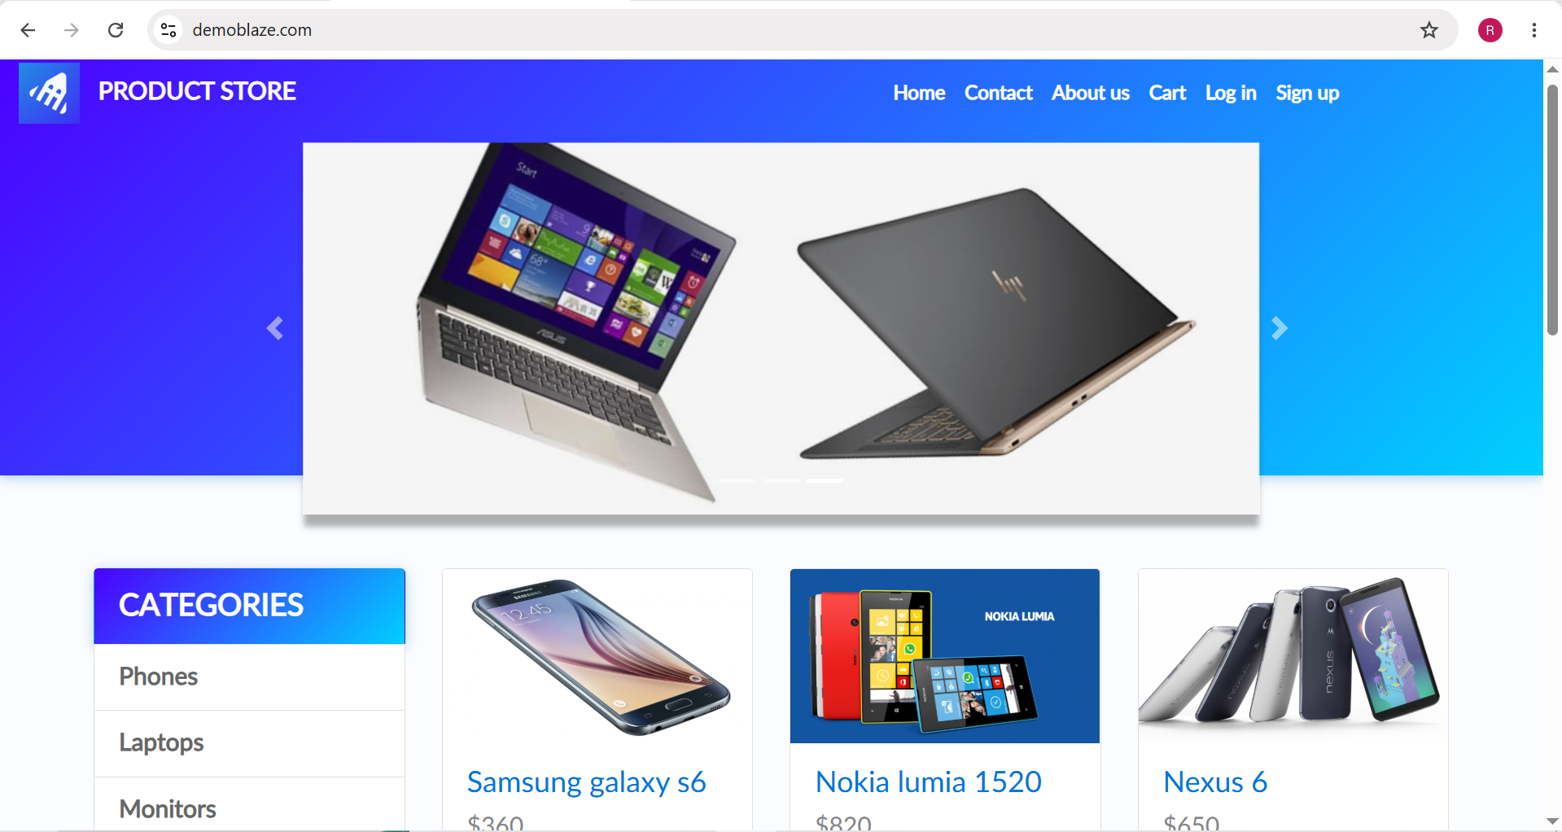

- Scenario ID: 3b
Scenario
Verify user can select a product
Test Steps
1. Open DemoBlaze homepage.
2. Locate Samsung galaxy s6.
3. Click the product.
4. Observe navigation.

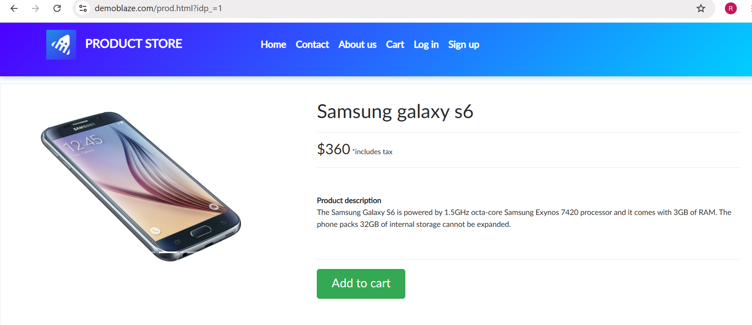

- Scenario ID: 3c
Scenario
Verify product details are displayed
Test Steps
1. Select Samsung galaxy s6.
2. Open product page.
3. Check product name.
4. Check price and description.
5. Check Add to cart button.

- Scenario ID: 3d
Scenario
Verify product can be added to cart
Test Steps
1. Open Samsung galaxy s6 product page.
2. Click Add to cart.
3. Observe confirmation message.
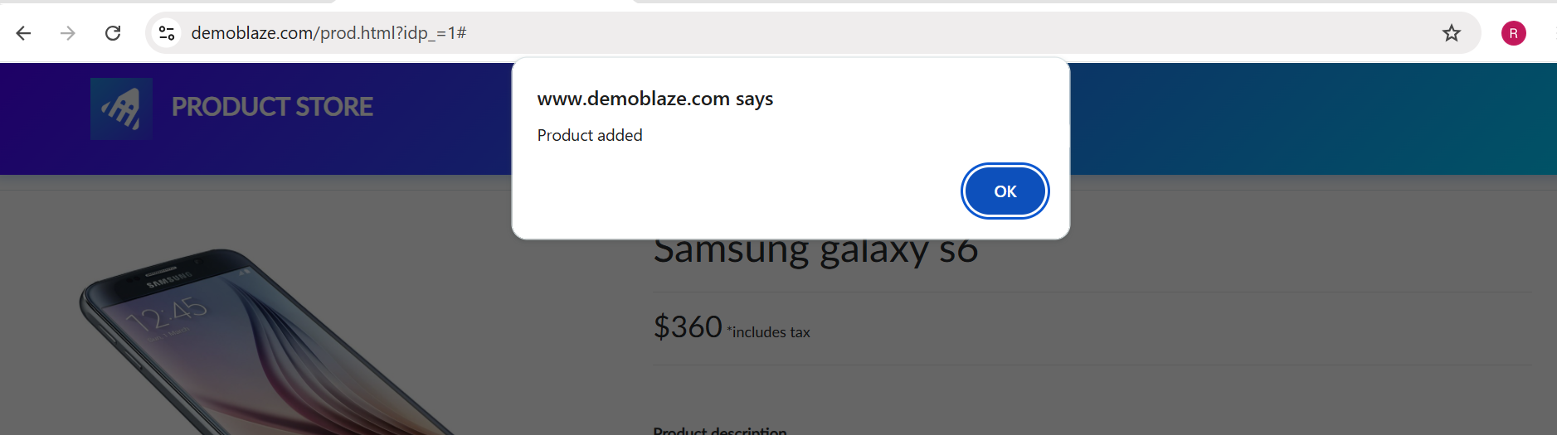

- Scenario ID: 3e
Scenario
Verify Cart page can be opened
Test Steps
1. Add Samsung galaxy s6 to cart.
2. Click OK on confirmation.
3. Click Cart from navigation.
4. Observe Cart page.
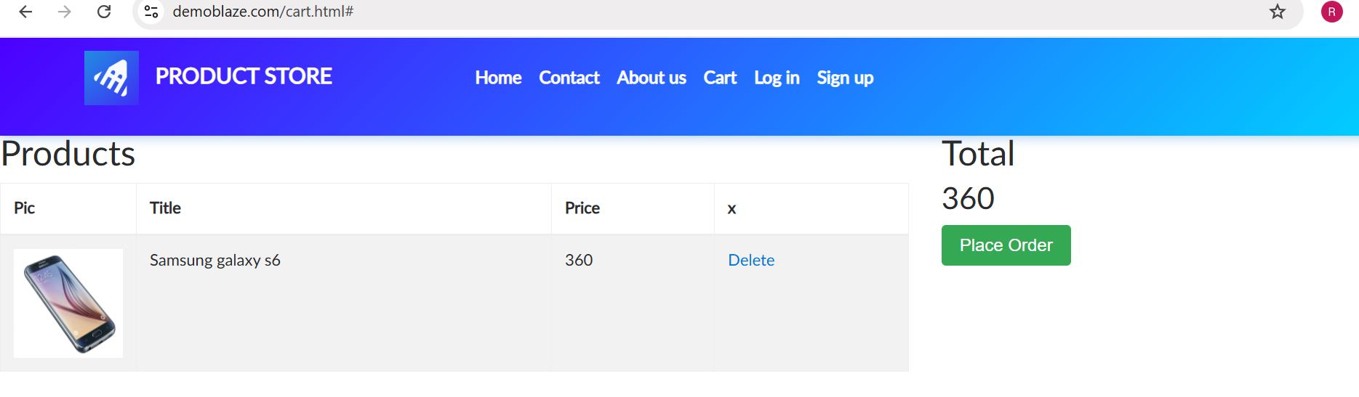

- Scenario ID: 3f
Scenario
Verify selected product is present in cart
Test Steps
1. Open Cart page.
2. Check product title.
3. Check product price.
4. Check total amount.

- Scenario ID: 3g
Scenario
Verify product can be removed from cart
Test Steps
1. Open Cart.
2. Locate Samsung galaxy s6.
3. Click Delete.
4. Wait for cart to update.
5. Observe the result.

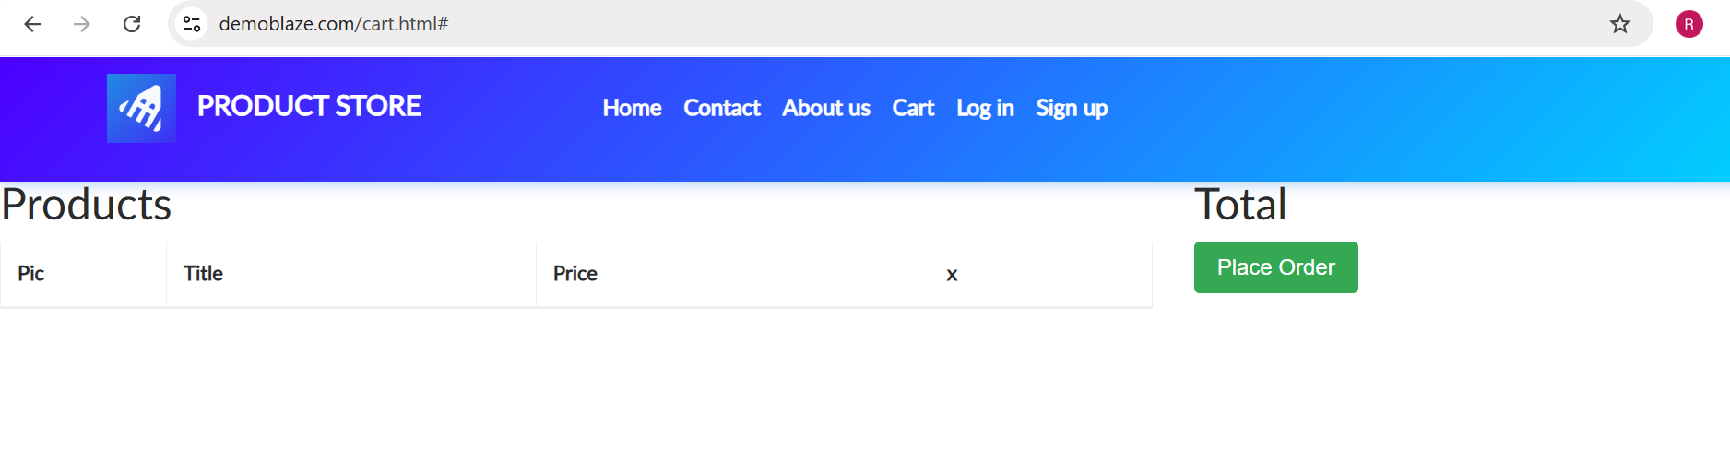

Requirement review table

Requirement | Clear / Unclear | Reason
User can view available products | Clear | Product listing can be directly verified.
User can select a product | Clear | Product selection and navigation are testable.
User can view product details | Clear | Name, price and description can be verified.
User can add a product to cart | Clear | Add-to-cart functionality is directly testable.
User can open the shopping cart | Clear | Cart navigation can be verified.
Added product should appear in cart | Clear | Product name and price can be compared with selected product.
User can remove a product from cart | Clear | Product removal can be verified visually.

Test Result Summary

Total Test Case | Pass | Fail
7 | 7 | 0

